

Structured Programming Language

Lab Report

**Submitted By,**

Name**:** Md. Tyibor Rahman

ID: 22100080

Dept: CSE

Batch: 24­th

Course-Code: CSE-135

Course Teacher: Md. Mizanur Rahman (Asst. Professor)

**INDEX**

|  |  |  |  |  |  |
| --- | --- | --- | --- | --- | --- |
| **Problem** | **Problem Name** | | | | **Page No** |
| **No** |  |  |  |  |  |
|  |  | | | |  |
| 01 | Write a C program that finds the Sum and Average of three integers. | | | | 3 |
|  |  | | | |  |
| 02 | Write a C program that convert given temperature in Fahrenheit to | | | | 5 |
|  | Celsius. |  |  |  |  |
|  |  | | | |  |
| 03 | Write a C program that determine an integer number is Even or Odd. | | | | 6 |
|  |  | | | |  |
| 04 | Write a C program to find the largest value among 3 numbers. | | | | 7 |
|  |  | | | |  |
| 05 | Write a C program that finds the grade of the given number | | | | 9 |
|  | (calculates the grading system). |  |  |  |  |
|  |  | | | |  |
| 06 | Write a C program that find the Factorial of a given integer number. | | | | 11 |
|  |  | | | |  |
| 07 | Write a C program to print and determine the sum of the following | | | | 13 |
|  | harmonic series for a given value of N: | | |  |  |
|  | 1+1/2+1/3+ ….. +1/N |  |  |  |  |
|  |  | | | |  |
| 08 | Write a C program to find the summation of the following series: | | | | 15 |
|  | 1/12+2/22+3/32+4/42+ …+N/N2 | | | |  |
|  |  | | | |  |
| 09 | Write a C program that print Fibonacci series of a given range. | | | | 17 |
|  |  | | | |  |
| 10 | Write a C program that checks whether the given number is a Prime. | | | | 19 |
|  |  | | | |  |
| 11 | Write a program to print the following pyramid | | | |  |
|  |  | 0 |  |  | 21 |
|  |  | 1 | 1 |  |  |
|  | 2 | 2 | 2 |  |  |
|  | 3 | 3 | 3 | 3 |  |
|  |  | | | |  |
| 12 | Write a C program that will perform addition of two dimensional array. | | | | 22 |
|  | array. |  |  |  |  |
|  |  |  |  |  |  |

**Problem No:** 1

**Problem Name:** Write a C program that finds the Sum and Average of three integers.

**Algorithm:**

Step 1: Start  
Step 2: Input a , b ,c  
Step 3: Calculate Sum=a + b + c  
Step 4: Show the Sum  
Step 5: Calculate Average=Sum/3.0  
Step 6: Show the Average  
Step 7: End

**Flow Chart:**

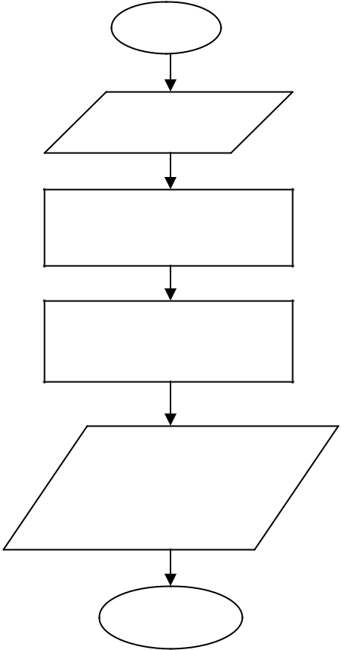

Start

Input a, b,c

Sum = a + b + c

Average = Sum/3.0

Show the sum

Show the average

End

**Program:**

#include<stdio.h>

int main()

{

int a,b,c,sum;

float avg;

printf("\nInput three integer: ");

scanf("%d%d%d",&a,&b,&c);

sum=a+b+c;

printf("\nSum=%d",sum);

avg=(a+b+c)/3.0;

printf("\nAvg = %.2f",avg);

return 0;

}

**Input:** Input three integer: 4 5 6

**Output:**

Sum = 15

Avg = 5.00

**Problem No:** 2

**Problem Name:** Write a C program that convert given temperature in Fahrenheit to Celsius.

**Algorithm:**

Step 1: Start.  
Step 2: Input temperature in Fahrenheit.  
Step 3: Calculate Celsius C= (Fahrenheit - 32) * 5 / 9 **or** C = (Fahrenheit - 32) / 1.8.  
Step 4: Show temperature in Celsius.  
Step 5: End.

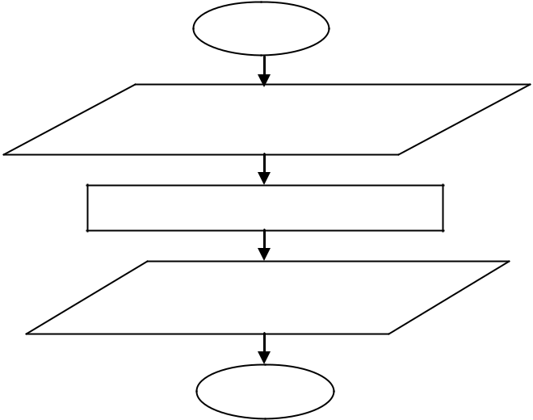**Flowchart:**

Start

Temperature in Fahrenheit

Celsius= (f - 32) * 5 / 9

Temperature in Celsius

End

**C-Code:**

#include<stdio.h>

void main(){

float f, c;

printf("Enter temperature in Fahrenheit: ");

scanf("%f",&f);

c= (f - 32) * 5 / 9;

printf("Result in Celsius is: %f",c);

}

**Input:** Enter temperature in Fahrenheit=55

**Output:**

Result in Celsius=12.777778

**Problem No:** 3

**Problem Name:** Write a C program that determine an integer number is Even or Odd.

**Algorithm:**

Step 1: Start.  
Step 2: Input A number.  
Step 3: Is number mod by 2 is Zero,

1. Yes, Print Even Number.
2. No, Print Odd Number.

Step 4: End

**Flowchart:**

Input A number

Odd Number

Even Number

If Number % 2 is 0

**C-Code:**

**Input** : Enter Any Number : 10  
**Output:** 10 is a Even number

void main(){

int n;

printf("Enter The number : ");

scanf("%d",&n);

if(n%2==0)

printf("Even number");

else

printf("Odd Number"); }

**Problem No:** 4

**Problem Name:** Write a C program to find the largest value among 3 numbers.

**Algorithm:**

Step 1: Start.  
Step 2: Input Three Number a b c.  
Step 3: Is Number   
 i) a > b and a > c, Print a  
 ii) b > a and b > c, Print b  
 iii) c >a and c > b, Print c

Step 4: End.

If Number

Print a

**Flowchart:**

Enter three number a,b,c

Print b

a > b and a > c b > a and b > c

Print c

**C-Code:**

#include<stdio.h>

int main(){

int a,b,c;

printf("Enter Three number : ");

scanf("%d%d%d",&a,&b,&c);

if(a>=b && a>=c){

printf("%d",a);

} else if(b>=a && b>=c){

printf("%d",b);

}else{

printf("%d",c);

}

return 0;

}

Input: Enter three numbers=12 8 30

Output: 30

**Problem No:** 5

**Problem Name:** Write a C program that finds the grade of the given number:

**Algorithm :**

Step 1 : Start

Step 2 : Read marks or Percentage

Step 3 : if marks >= 80 then grade =A, go to step 7

Step 4 : if marks >= 60 and marks <=80 then grade = B, go to step 7

Step 5 : if marks >=40 and marks <=60 then grade = C go to step 7

Step 6 : display failed

Step 7 : stop.

**Flowchart:**

Read Marks

Marks >= 60 and <= 80

Marks >= 60 and <= 80

Marks > 80

Display Fail

Display grade = C

Display grade = B

Display grade = A

**C-Code:**

#include <stdio.h>

int main(void)

{

int num;

printf("Enter your mark ");

scanf("%d",&num);

if(num >= 80){

printf(" You got A+ ");

}

else if ( num >=60){

printf(" You got B");

}

else if ( num >=40){

printf(" You got C");

}

else if ( num < 40){

printf(" You Failed in this exam n");

}

return 0;

}

Input: Enter your marks=88

Output: A+

**Problem No:** 6

**Problem Name:** Write a C program that find the Factorial of a given integer number.

**Algorithm :**

**Step 1**: Start   
**Step 2**: Read a number n  
**Step 2**: Initialize variables: i = 1, fact = 1   
**Step 3**:  if i <= n go to step 4 otherwise go to step 7  
**Step 4**: Calculate fact = fact * i  
**Step 5:** Increment the i by 1 (i=i+1) and go to step 3  
**Step 6:** Print fact  
**Step 7:** Stop

**Flowchart:**

fact = fact * i

Print fact

i = I + 1

Is i<=n

i = 1

fact = 1

Read n

**C-Code:**

#include <stdio.h>

int factorial(int);

int main()

{

  int num, fact = 1, result;

  //user input

  printf("Enter the number to find factorial: ");

  scanf("%d", &num);

  result = factorial(num);  //function call

//display

  printf("Factorial of %d is: %d\n", num, result);

  return 0;

}

//function to find factorial

int factorial(int num)

{

  int i, fact = 1;

//factorial calculation

  for (i = 1; i <= num; i++)

    fact = fact * i;

  return (fact);

}

Input: Enter any positive number: 4

Output: 24

**Problem No:** 7

**Problem Name:** Write a C program to print and determine the sum of the following harmonic series for a given value of N

1+1/2+1/3+ ….. +1/N

**Algorithm :**

**Step 1**: Start   
**Step 2**: Read a number n  
**Step 2**: Initialize variables: i = 1, sum = 0   
**Step 3**:  if i <= n go to step 4 otherwise go to step 6  
**Step 4**: Calculate sum = sum + (1/i)  
Step 5: print (1/i)  
**Step 6:** Print sum  
**Step 7:** Stop

**Flowchart:**

i = I + 1

Print (1/i)

Sum = sum + (1/i)

Is i<=n

i = 1

sum = 0

Read n

Print sum

**C-Code:**

#include <stdio.h>

int main()

{

float n ,sum;

printf("Enter A number: ");

scanf("%f",&n);

for(float i = 1; i <= n; i++){

printf(" %.2f",(1/i));

sum = sum + (1/i);

}

printf("\n Sum of Series : %f",sum);

return 0;

}

**Problem No:** 8

**Problem Name:** Write a C program to print and determine the sum of the following harmonic series for a given value of N 1/12+2/22+3/32+4/42+ …+N/N2

**Algorithm :**

**Step 1**: Start   
**Step 2**: Read a number n  
**Step 2**: Initialize variables: i = 1, sum = 0   
**Step 3**:  if i <= n go to step 4 otherwise go to step 6  
**Step 4**: Calculate sum = sum + (i/(i*i))  
**Step 6:** Print sum  
**Step 7:** Stop

**Flowchart:**

i = I + 1

Sum = sum + (1/i)

Is i<=n

i = 1

sum = 0

Read n

Print sum

**C-Code:**

#include <stdio.h>

int main()

{

float n ,sum;

printf("Enter A number: ");

scanf("%f",&n);

for(float i = 1; i <= n; i++){

sum = sum + (i/(i*i));

}

printf("\n Sum of Series : %f",sum);

return 0;

}

**Problem No:** 9

**Problem Name:** Write a C program that print Fibonacci series of a given range.

**Algorithm :**

**Step 1**: Start   
**Step 2**: Declare variables I , a , b , show  
**Step 2**: Initialize the variables, a=0, b=1, and show =0  
Step 3: Enter the number of terms of Fibonacci series to be printed  
Step 4: Print First two terms of series   
 1. Show = a + b  
 2. a = b  
 3. b = show  
 4. increase value of i each time by 1  
 5. print the value of show

Step 6: End

Declare Variable I,n,a,b,show  
Initialization a=0,b=1 and show= 0 ,i= 2

**Flowchart:**

Print show

Show = a+b  
a=b  
b = show,++i

Is i<=n

The Fabonacci Series: \n\n\n a , b

Input the number of term to be printed

**C-Code:**

#include <stdio.h>

int main() {

int i, n;

int a = 0, b = 1;

int show = a + b;

printf("Enter the number of terms: ");

scanf("%d", &n);

printf("Fibonacci Series: %d, %d, ", a, b);

for (i = 3; i <= n; ++i) {

printf("%d, ", show);

a = b;

b = show;

show = a + b;

}

return 0;

}

**INPUT:** Enter the number of terms: 5

**OUTPUT:** Fibonacci Series: 0, 1, 1, 2, 3

**Problem No:** 10

**Problem Name:** Write a C program that checks whether the given number is a Prime.

**Algorithm :**Step_1) Start  
Step_2) Input Number  
Step_3) set, i = 2 and count = 0  
Step_4) Is i < number  
 i) Yes, go to step 5  
 ii) No, go to step 4  
Step_5) Is number mod i is 0  
 i) Yes, count++,go to step 5  
 ii) No, go to step 4  
Step_6) Is (count==0)  
 i) Yes, print the number is prime  
 ii) No, print the number is not prime

**Flowchart:**

Print “No not prime”

Print No Prime

i = I + 1

n % I == 0

Is i<=n

n == I == 0

Read n

i = 2

**C-Code:**

#include<stdio.h>

void main()

{

int i,n,count;

count=0;

printf("Enter any number: ");

scanf("%d",&n);

for(i=2; i <n ; i++)

{

if(n%i==0)

{

count++;

break;

}

}

if(count==0)

printf("%d is a Prime Number",n);

else

printf("%d is Not a Prime Number",n);

}

**INPUT: Enter any number: 3**

**OUTPUT: 3 is a Prime Number**

**Problem No:** 11

**Problem Name:** Write a program to print the following pyramid

0

1 1

2 2 2

3 3 3 3

**C-Code:**

#include <stdio.h>

void main()

{

int i, j, rows, k = 0;   
 printf (" Enter a number: \n");

scanf ("%d", &rows);

for ( i =1; i <= rows; i++)

{

for ( j = 1; j <= rows - i; j++) {

printf (" ");

}

for ( k = 1; k <= ( 2 * i - 1); k++)

{

printf ("%d ",i);

}

printf ("\n");

}

}

**Problem No:** 12

**Problem Name:** Write a C program that will perform addition of two dimensional array.

**C-Code:**

#include <stdio.h>  
void main()  
{   
int test1[2][2],test2[2][2];  
 printf("Enter First arrays values: ");  
 for(int i= 0;i<2;i++){  
 for(int j = 0;j<2;j++){  
 scanf("%d",&test1[i][j]);  
 }  
 }  
 printf("Enter Second arrays values: ");  
 for(int i= 0;i<2;i++){  
 for(int j = 0;j<2;j++){  
 scanf("%d",&test2[i][j]);  
} }

printf("Now Sum Result of Two Array is \n");  
 for(int i= 0;i<2;i++){  
 for(int j = 0;j<2;j++){  
 printf(" %d",((test1[i][j])+(test2[i][j])));  
 }  
 }  
}